11/12/2018

*Group name Genesis*

*Name USI*

*Kelvin Morrison 1028679*

*Rayon Wilson 1028654*

*Noel Farley 1027234*

*Valon Madramootoo 1028391*

*Zhi Cheng Su 102141*

LECTURER NAME alicia layne

CSE 2101 SOFTWARE ENGINEERING 1

SEMESTER PROJECT

Description of the mock-up diagrams

There are four main process depicted in these diagrams.

* Main login page.
* Administrator page
* managers/ dispatchers page
* And the driver page

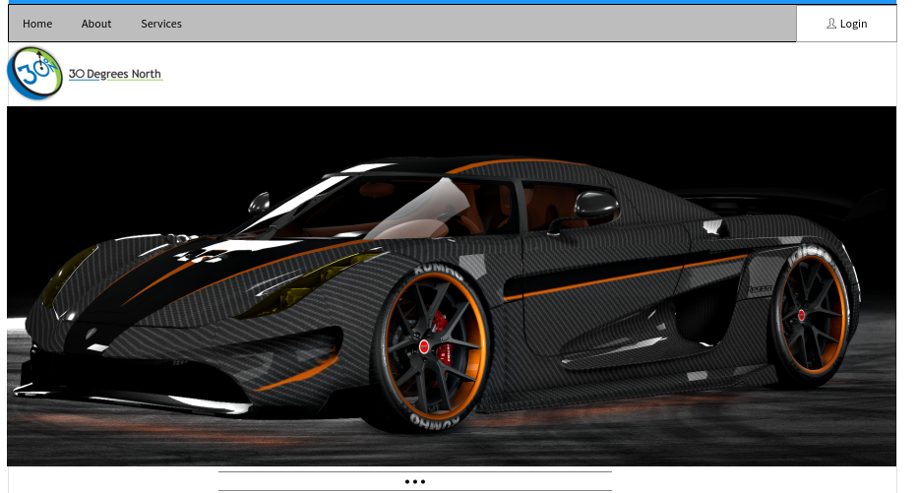

Main login page

This will be available to all user since a user must be login before he/she can use the system to edit or receive data. This has three extension tabs. Namely “home”, “about”,” services” these tabs will have extension links to other pages that will give the details under their respective headings.

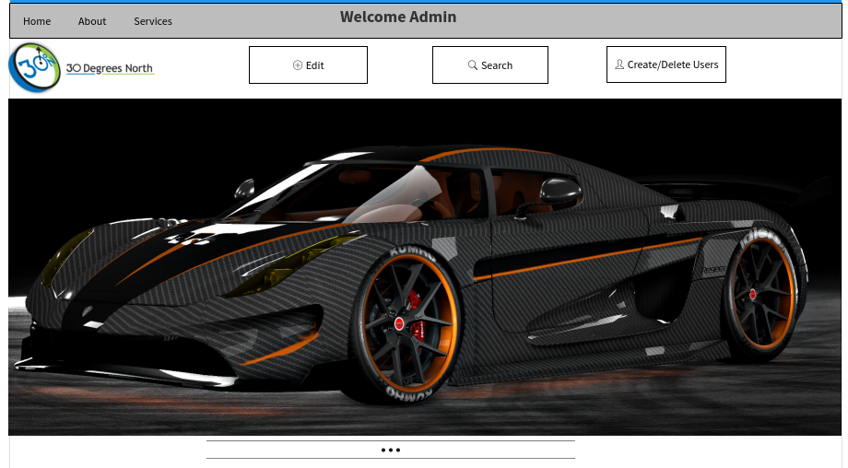

Administrative page

This page can only be access by someone with administrative privileges, also all other account is created or destroy from this page. All elevated action regarding the entire application can be edited from this page.

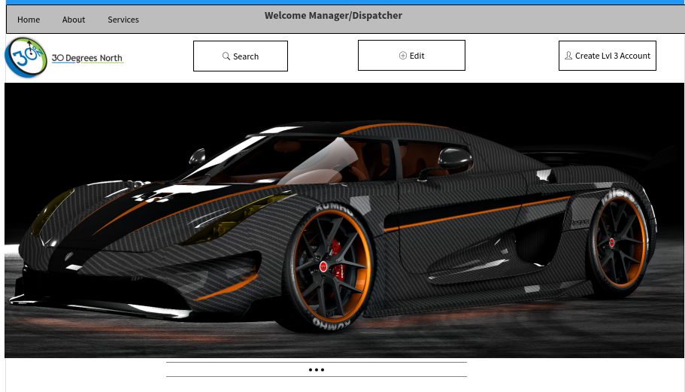

Managers/dispatchers pages

Allows for level three login creation (drivers user account) and minor searches that will be vital to the day to day activities of the business.

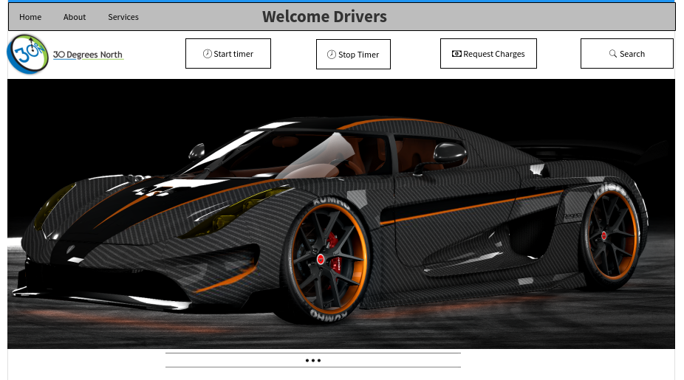

Drivers page

This page has the most functionalities but all of which had very limited privileges. A driver will only gain access to the application if an account is created by the administrator or a manager/dispatcher. Drivers are allowing to do searches for location, start the timing process and stop it also request for invoices.

Architectural design of the Timetracker software application.

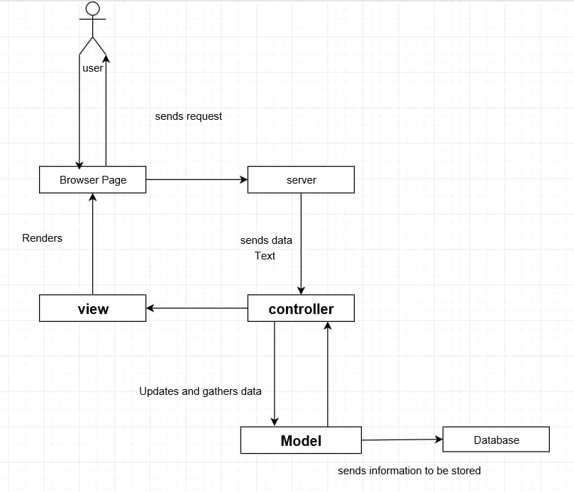

The software architecture that is more appropriate to describe our application is the layered architecture.

The Model-View-Controller (MVC) is an architectural pattern that separates an application into three main logical components: the model, the view, and the controller. Each of these components are built to handle specific development aspects of an application. MVC is one of the most frequently used industry-standard web development frameworks to create scalable and extensible projects.

The user interacts with a web browser that contain many features. If the user sends or update information from the. The browser will then send the request from the user to the server. The server will therefore send the data to the controller that will check the data for what action the user requires. The controller will then send the update information or request to the model. The model will then send the information to the database to be saved or retrieve additional information from it and send it back to the controller. The controller will then send the data to the view in which it will render the information and update the page to the user providing him with the changed or requested information.